Algorithm (Product Class)

Create and Display Products
- Start
- Define a class Product
- Declare attributes:
  - productID
  - productName
  - price
  - quantity
- Create a parameterized constructor to initialize values
- Create a copy constructor to copy values from another object
- Create a destructor
- Define a method display() to show product details
- In main():
  - Create a vector/array of Product objects
  - Add multiple products using constructor
  - Use loop to display all products
- End
Code:
#include <iostream>
#include <vector>
using namespace std;

class Product {
private:
int productID;
string productName;
double price;
int quantity;

public:
// Parameterized Constructor
Product(int id, string name, double p, int q) {
productID = id;
productName = name;
price = p;
quantity = q;
}

// Copy Constructor
Product(const Product &p) {
productID = p.productID;
productName = p.productName;
price = p.price;
quantity = p.quantity;
}

// Destructor
~Product() {
// optional
}

// Display Function
void display() {
cout << "ID: " << productID
<< ", Name: " << productName
<< ", Price: " << price
<< ", Quantity: " << quantity << endl;
}
};

int main() {
vector<Product> products;

products.push_back(Product(1, "Laptop", 1000, 2));
products.push_back(Product(2, "Phone", 500, 3));
products.push_back(Product(3, "Tablet", 300, 4));

cout << "Product List:\n";
for (auto &p : products) {
p.display();
}

return 0;
}
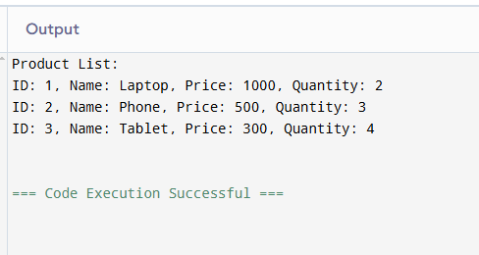

Algorithm (Shopping Cart System)

Shopping Cart Operations
- Start
- Define class ShoppingCart
- Declare:
  - cartID
  - dynamic list (vector) of products
- Create constructor to initialize cartID

Add Product Algorithm
- Take product as input
- Add product to vector using push_back()
- Display updated cart

Remove Product Algorithm
- Take productID as input
- Search product in vector
- If found:
  - Remove product using erase()
  - Display updated cart
- Else:
  - Show "Product not found"

Update Quantity Algorithm
- Take productID and new quantity
- If quantity < 0:
  - Show error message
- Else:
  - Search product
  - If found → update quantity
  - Else → show error
- Display updated cart

Calculate Total Algorithm
- Initialize total = 0
- For each product in cart:
  - total += price × quantity
- Return total

Display Cart Algorithm
- Loop through all products
- Call display() for each product
- Show total cart value
Code:
#include <iostream>
#include <vector>
using namespace std;

class Product {
private:
int productID;
string productName;
double price;
int quantity;

public:
Product(int id, string name, double p, int q) {
productID = id;
productName = name;
price = p;
quantity = q;
}

int getID() { return productID; }
double getPrice() { return price; }
int getQuantity() { return quantity; }

void setQuantity(int q) { quantity = q; }

void display() {
cout << "ID: " << productID
<< ", Name: " << productName
<< ", Price: " << price
<< ", Quantity: " << quantity << endl;
}
};

class ShoppingCart {
private:
int cartID;
vector<Product> products;

public:
ShoppingCart(int id) {
cartID = id;
}

void addProduct(Product p) {
products.push_back(p);
cout << "Product added.\n";
displayCart();
}

void removeProduct(int id) {
for (int i = 0; i < products.size(); i++) {
if (products[i].getID() == id) {
products.erase(products.begin() + i);
cout << "Product removed.\n";
displayCart();
return;
}
}
cout << "Product not found!\n";
}

void updateQuantity(int id, int q) {
if (q < 0) {
cout << "Invalid quantity!\n";
return;
}

for (int i = 0; i < products.size(); i++) {
if (products[i].getID() == id) {
products[i].setQuantity(q);
cout << "Quantity updated.\n";
displayCart();
return;
}
}
cout << "Product not found!\n";
}

double calculateTotal() {
double total = 0;
for (auto &p : products) {
total += p.getPrice() * p.getQuantity();
}
return total;
}

void displayCart() {
cout << "\nCart Details:\n";
for (auto &p : products) {
p.display();
}
cout << "Total: " << calculateTotal() << endl;
}
};

int main() {
ShoppingCart cart(101);

cart.addProduct(Product(1, "Laptop", 1000, 2));
cart.addProduct(Product(2, "Phone", 500, 3));

cart.updateQuantity(1, 5);
cart.removeProduct(2);

return 0;
}
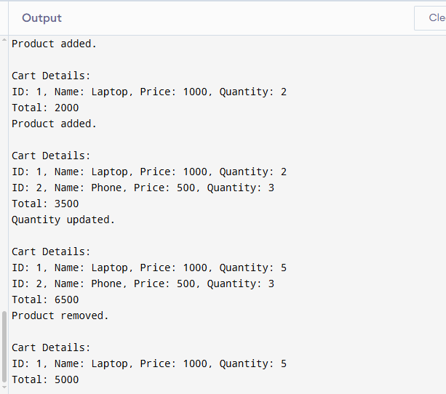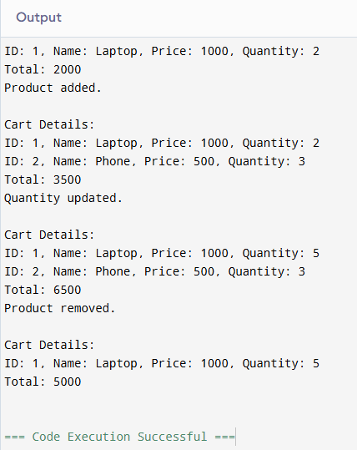

Task 3: Algorithm (Discounted Product)

Algorithm: Discount Calculation
- Start
- Create derived class DiscountedProduct from Product
- Add attributes:
  - discountPercentage
  - discountType

Calculate Discounted Price
- Get original price
- Calculate discount = price × (discountPercentage / 100)
- If quantity > 5:
  - Add extra 5% discount
- Final price = price − total discount
- Return final price

Display Method (Override)
- Call base class display()
- Show discount percentage and type
- Show final discounted price

Code:
#include <iostream>
using namespace std;

class Product {
protected:
int productID;
string productName;
double price;
int quantity;

public:
Product(int id, string name, double p, int q) {
productID = id;
productName = name;
price = p;
quantity = q;
}

double getPrice() { return price; }
int getQuantity() { return quantity; }

virtual void display() {
cout << "ID: " << productID
<< ", Name: " << productName
<< ", Price: " << price
<< ", Quantity: " << quantity << endl;
}
};

class DiscountedProduct : public Product {
private:
double discountPercentage;
string discountType;

public:
DiscountedProduct(int id, string name, double p, int q,
double d, string type)
: Product(id, name, p, q) {
discountPercentage = d;
discountType = type;
}

double getDiscountedPrice() {
double discount = price * (discountPercentage / 100);

// Extra rule
if (quantity > 5) {
discount += price * 0.05;
}

return price - discount;
}

void display() override {
cout << "Discounted Product:\n";
Product::display();
cout << "Discount: " << discountPercentage << "% (" << discountType << ")\n";
cout << "Final Price: " << getDiscountedPrice() << endl;
}
};

int main() {
DiscountedProduct dp(3, "Headphones", 200, 6, 10, "Seasonal");
dp.display();

return 0;
}
Output:
